ChromeDriver Installation
Step 1: Check Installed Chrome Version
CHROME_VERSION=$(google-chrome --version | awk '{print $3}' | cut -d'.' -f1-3)
This extracts the Chrome version and stores it in the variable CHROME_VERSION.
Step 2: Install curl
sudo apt install curl
curl is required to fetch data from URLs in the terminal.
Step 3: Install jq
sudo apt install jq
jq is required to read and parse JSON responses.
Step 4: Get Matching ChromeDriver Version
LATEST_DRIVER=$(curl -s "https://googlechromelabs.github.io/chrome-for-testing/
latest-patch-versions-per-build.json" | jq -r ".builds[\"$CHROME_VERSION\"].version")
This fetches the correct ChromeDriver version matching the installed Chrome version.
if curl not installed
sudo apt install curl
Step 5: Download ChromeDriver
wget https://storage.googleapis.com/chrome-for-testing-public/
$LATEST_DRIVER/linux64/chromedriver-linux64.zip
Step 6: Extract the File
unzip chromedriver-linux64.zip
Step 7: Move ChromeDriver to System Path
sudo mv chromedriver-linux64/chromedriver /usr/local/bin/
Step 8: Give Execute Permission
sudo chmod +x /usr/local/bin/chromedriver
Step 9: Verify Installation
chromedriver --version
The version displayed must match the installed Chrome version.

Program 3: Maven Selenium Project – Automating Product Click on AutomationExercise (Chrome)
Project Creation Procedure
Step 1: Create Maven Project
mvn archetype:generate -DgroupId=com.example -DartifactId=MyMavenSeleniumChrome1 \
-DarchetypeArtifactId=maven-archetype-quickstart -DinteractiveMode=false
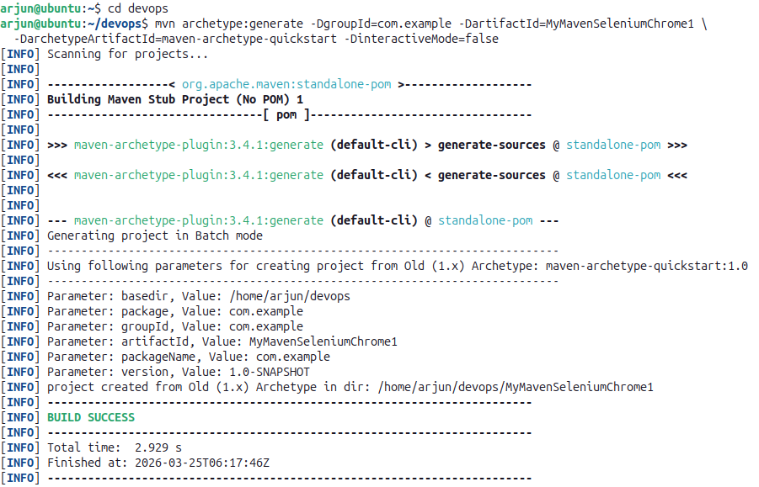

Step 2: Navigate to the Project Directory
cd MyMavenSeleniumChrome1
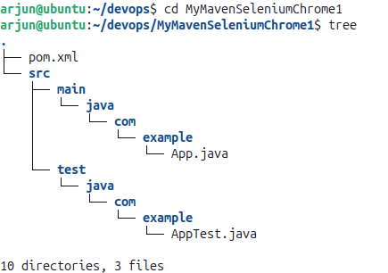
tree

Step 3: Inspect Website Elements
Open https://automationexercise.com/ in Chrome. Right-click → Inspect. Use cursor tool to find the product button.
Attribute | Value
data-product-id | 1
Selector used | a[data-product-id='1']

Step 4: Edit pom.xml
gedit pom.xml
pom.xml
<project xmlns="http://maven.apache.org/POM/4.0.0"
xmlns:xsi="http://www.w3.org/2001/XMLSchema-instance"
xsi:schemaLocation="http://maven.apache.org/POM/4.0.0
http://maven.apache.org/maven-v4_0_0.xsd">
<modelVersion>4.0.0</modelVersion>
<groupId>com.example</groupId>
<artifactId>MyMavenSeleniumApp01</artifactId>
<packaging>jar</packaging>
<version>1.0-SNAPSHOT</version>
<name>MyMavenSeleniumApp01</name>
<url>http://maven.apache.org</url>
<dependencies>
<dependency>
<groupId>junit</groupId>
<artifactId>junit</artifactId>
<version>3.8.1</version>
<scope>test</scope>
</dependency>
<!-- Selenium: Browser automation library -->
<dependency>
<groupId>org.seleniumhq.selenium</groupId>
<artifactId>selenium-java</artifactId>
<version>4.29.0</version>
</dependency>
</dependencies>
<build>
<plugins>
<plugin>
<groupId>org.apache.maven.plugins</groupId>
<artifactId>maven-compiler-plugin</artifactId>
<version>3.8.1</version>
<configuration>
<source>1.7</source>
<target>1.7</target>
</configuration>
</plugin>
<plugin>
<groupId>org.apache.maven.plugins</groupId>
<artifactId>maven-surefire-plugin</artifactId>
<version>2.22.2</version>
</plugin>
<plugin>
<groupId>org.apache.maven.plugins</groupId>
<artifactId>maven-jar-plugin</artifactId>
<version>3.0.1</version>
<configuration>
<archive>
<manifestEntries>
<Main-Class>com.example.App</Main-Class>
</manifestEntries>
</archive>
</configuration>
</plugin>
</plugins>
</build>
</project>
Step 5: Modify App.java
cd src/main/java/com/example/
gedit App.java
App.java
package com.example;

import org.openqa.selenium.By;
import org.openqa.selenium.WebDriver;
import org.openqa.selenium.WebElement;
import org.openqa.selenium.chrome.ChromeDriver;
import org.openqa.selenium.JavascriptExecutor;

public class App {
public static void main(String[] args) throws InterruptedException {
// Initialize ChromeDriver and open browser
WebDriver driver = new ChromeDriver();
driver.manage().window().maximize();

// Open AutomationExercise website
driver.get("https://automationexercise.com/");
Thread.sleep(3000);

// Remove iframe ads using JavaScript
JavascriptExecutor js = (JavascriptExecutor) driver;
js.executeScript("document.querySelectorAll('iframe').forEach(e => e.remove());");

// Locate product with data-product-id='1'
WebElement element = driver.findElement(By.cssSelector("a[data-product-id='1']"));

// Scroll element into view and click
js.executeScript("arguments[0].scrollIntoView(true);", element);
js.executeScript("arguments[0].click();", element);
Thread.sleep(3000);

driver.quit();
}
}

Step 6: Compile the Project
mvn clean install
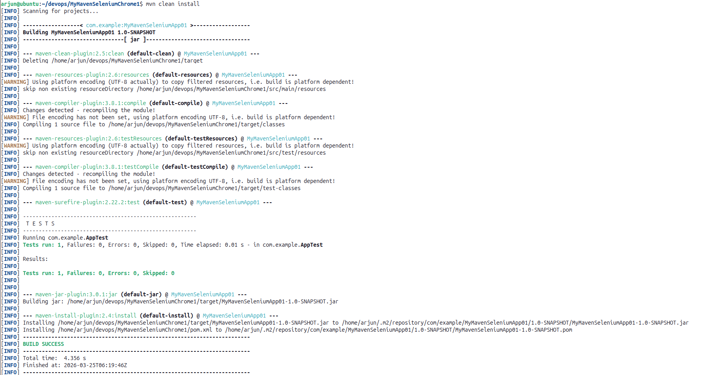

Step 7: Run the Application
mvn exec:java -Dexec.mainClass="com.example.App"
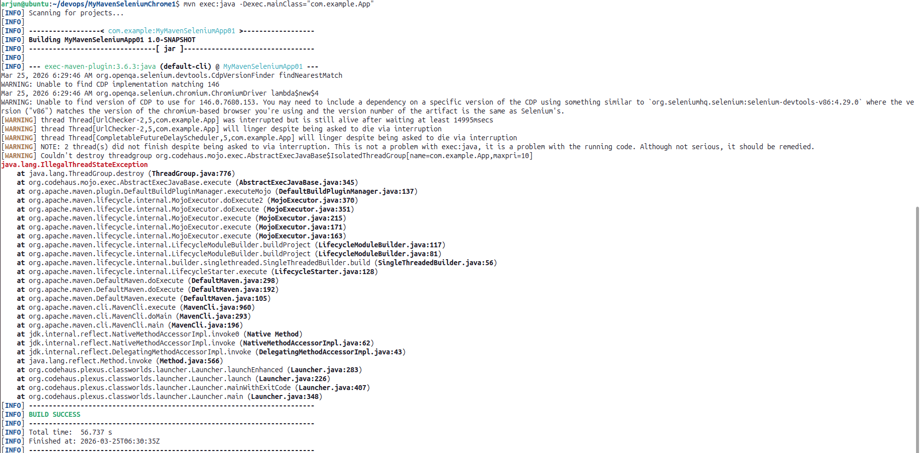

Output
Chrome browser launches automatically, opens the AutomationExercise homepage, removes all iframe advertisement overlays, scrolls to the first product, clicks on it, and the product detail modal appears. Browser closes after 3 seconds. Terminal shows BUILD SUCCESS.

